**Spinners**

To create a spinner/loader, use the .spinner-border class:

**Example :**

<div class="container mt-3">

<h2>Spinners</h2>

<p>To create a spinner/loader, use the <code>.spinner-border</code> class:</p>

<div class="spinner-border"></div>

</div>

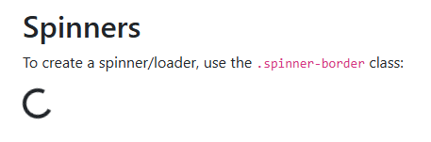

**Colored Spinners**

Use any text color utilites to add a color to the spinner:

<div class="container mt-3">

<h2>Colored Spinners</h2>

<p>Use any <strong>text color utilites</strong> to add a color to the spinner:</p>

<div class="spinner-border text-muted"></div>

<div class="spinner-border text-primary"></div>

<div class="spinner-border text-success"></div>

<div class="spinner-border text-info"></div>

<div class="spinner-border text-warning"></div>

<div class="spinner-border text-danger"></div>

<div class="spinner-border text-secondary"></div>

<div class="spinner-border text-dark"></div>

<div class="spinner-border text-light"></div>

</div>

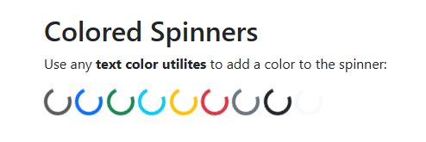

**Spinner Buttons**

<div class="container mt-3">

<h2>Spinner Buttons</h2>

<p>Add spinners to buttons:</p>

<button class="btn btn-primary">

<span class="spinner-border spinner-border-sm"></span>

</button>

<button class="btn btn-primary">

<span class="spinner-border spinner-border-sm"></span>

Loading..

</button>

<button class="btn btn-primary" disabled>

<span class="spinner-border spinner-border-sm"></span>

Loading..

</button>

<button class="btn btn-primary" disabled>

<span class="spinner-grow spinner-grow-sm"></span>

Loading..

</button>

</div>

